**The Cal Command for Calendar**

If a user wants a quick view of calendar in Linux terminal, cal is the command for you. By default, cal command shows current month calendar as output.

**cal** command is a calendar command in Linux which is used to see the calendar of a specific month or a whole year.

In the following example I have displayed the calendar of a particular month and year AND the whole calendar of an year.

This is the screen shot when a particular month of a year is displayed.

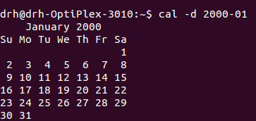

This is the screen shot when whole year is displayed.

